TASK # 03:

Question 1: Can a friend function be used to overload an operator that modifies the

invoking object?

Problem Statement:

Consider the += operator, which modifies the left-hand operand. Can a friend function be used

to overload this operator?

* If yes, how should it be implemented?
* If no, what alternative approach should be used?

**Ans: Yes, a friend function can be used to overload the += operator. A friend function has access to the private and protected members of the class, which allows it to modify the object.**

**Code:**

#include<iostream>

using namespace std;

class temp{

    private:

int a;

public:

temp(int a=0):a(a){}

friend temp& operator+=( temp& obj,const temp&obj2);

void display()const{

    cout<<"Value: "<<a<<endl;

}

};

temp&operator+=( temp& obj,const temp&obj2){

    obj.a+=obj2.a;

    return obj;

}

int main() {

   temp obj1(10), obj2(20);

    obj1 += obj2;

    obj1.display();

    return 0;

}

**Output:**

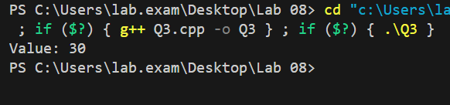

Question 2: Is it possible to overload an operator using a friend function if one of the

operands is a primitive data type?

Problem Statement:

Suppose we want to overload the + operator to allow addition between an object and a primitive

type (e.g., object + int).

* Can a friend function handle this case?
* If yes, how would it be implemented?
* If no, what limitations exist?

**Ans:**

Question 3: Can a friend function access private and protected members of a class without

using an object of that class?

Problem Statement:

A friend function is granted access to private and protected members of a class.

* Does it always need an object to access these members?
* Can a friend function access them directly without an object?
* Under what conditions might it fail?

**Ans: Yes, it always need the object to access these members, because it is not member function of class so it can not access the member directly, we have to pass the object of that class.**